***CTEC 4309 Final Review***

1. *Quiz Answers*
2. *His Notes about the Final [what you need to know]*
   1. *My compiled notes will be in red*

**Quiz 5:**

1. BBB online and Trustee are examples of TRUSTED THIRD PARTY OFFER SEALS ON PRIVACY PROTECTION
2. How many pages did research find that people viewed on average on most web sites? = LESS THAN 3 PAGES
3. According to the research mentioned in class, to gain a competitive advantage, how fast should a web site respond to user requests? = 250ms
4. Which of the following is NOT a good way to increase credibility for online stores? = USING ALIASES INSTEAD OF REAL NAMES
5. For an e-commerce web site, from a marketing perspective, what will you suggest to add to their most popular entry pages? = BE ABLE TO LIST 2 SUGGESTIONS!

**Quiz 6:**

1. Applying clickstream analysis to web site traffic data can find ALL THE ABOVE/BELOW
   1. REFERRAL LOCATIONS OF WEB SITE VISITORS
   2. SURFING PATHS OR PATTERNS OF WEB SITE VISITPORS
   3. APPROX HOW MUCH TIME VISITORS SPENT ON WEB SITE
2. Which of the following is not a typical benefit of online marketing research = REPRESENTATIVE
3. What is data mining? = DATA ANALYSIS WITH NO PRESET HYPOTHESIS
4. Which of the following research method is best for inquiring why your new product receives lower rating than your competitors? = SURVEY
5. What are some sources for competitive intelligence (*about your competitors*)?

= BE ABLE TO LIST 2!

**Quiz 7:**

1. The windows startup menu may change automatically based on how often each application is used. Which of the following mass customization approaches does this example illustrate? = COLLABORATIVE.
2. Which one of the following is a potential issue resulting from personalization?

= FIRST-CLASS ENVY

1. Some of the cell phone handsets allow you to choose your favorite color. It illustrates which of the following mass customization approaches? = COSMETIC
2. Based on class discussion, which one of the following choice assistance systems is ideal for products that have a complex and qualitative attributes (such as music) and serve a wide range of customer needs? = COLLABORATIVE FILTERING
3. What are some benefits of personalization? = BE ABLE TO LIST 2!

**Quiz 8:**

1. Why should a company sell directly online? = ALL OF THE BAOVE/BELOW
   1. TO PROVIDE PRODUCT CUSTOMIZATION
   2. TO EXPLORE NEW PROFIT SOURCES
   3. TO BETTER PREPARE FOR BREAKDOWNS IN TRADITIONAL OFFLINE CHANNELS
2. The long tail discussed in class refers to? = THE DIFFICULTY IN SUPPLYING ITEMS WHICH ARE HARD TO FIND IN OFFLINE STORES
3. What does channel conflict refer to? = THE DIFFERENT DISTRIBUTION CHANNELS YOU USE COMPETING FOR THE SAME CUSTOMER BASE
4. How much did e-commerce sales account for total retail sales in the US last year (2014)? = 6.5%
5. Please provide an example illustrating the multi-channel approach we discussed in class

**Quiz 9:**

1. Which of the following trends is correct? = THERE ARE MORE WIRELESS PHONE USERS THAN DESKTOP PC USERS GLOBALLY
2. How can various wireless infrastructures help CRM? = ALL THE BAOVE/BELOW
   1. TRACKING CUSTOMERS
   2. PROVIDING CONTENTS AND SERVICES AT THE TIME OF NEED
   3. PROVIDING HIGHLY ENGAGING CONTENTS
3. According to the studies discussed in class, which one of the following factors influence people’s perceived value of mobile advertising? = ALL THE ABOVE/BELOW
   1. INFORMATION VALUE OF THE MOBILE AD
   2. ENTERTAINMENT VALUE OF THE MOBILE AD
   3. ADVERTISERS CREDIBILITY
4. Please provide 1 of the 4 marketing propositions for m-commerce discussed in class
5. Comparing to stationary devices, what are some marketing advantages of wireless devices? = BE ABLE TO LIST 2!

MAKE SURE YOU KNOW THE FOLLOWING! FROM DR. JANG’S LAST CLASS …

* IPACE model INFORMATION / PRICE / ASSORTMENT / CONVENIENCE / ENTERTAINMENT
  + Especially know the C is for convenience





* Distribution of products.. B2B, B2C, C2C, C2B
  + C2B would be like selling a blog, or using your site’s adspace
  + Know the “*why*”.. why sell directly to consumers.. what about indirect or a  mix approach. What is advantage of selling directly online? Why do some companies still use intermediaries.. like eBay.. ?
* Information
  + Evaluative Alternatives
    - Search goods vs experience goods
    - Example: search goods 🡪 quality is predictable.. like a hard drive
    - Example: experience goods 🡪 a haircut
  + Price 🡪 always cheaper online? Not always.. prices can fluctuate alot
* Understand selling the long tail. This is advantageous for shelf space by selling online

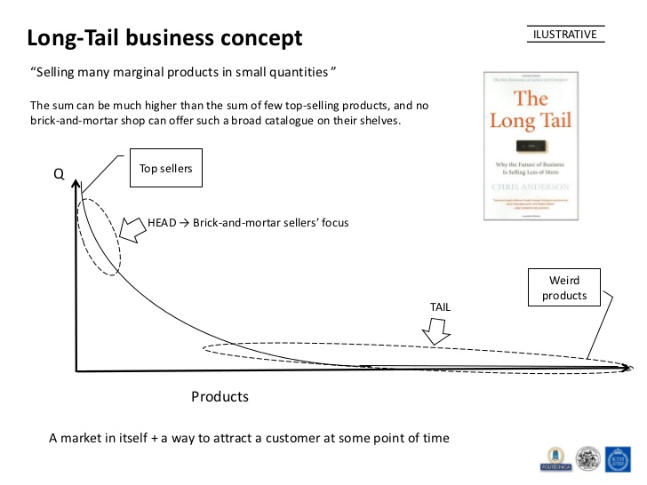

* Credibility cues
  + how to set up on website
  + Cred. Cues on websites should do the following:
    - Easy to verify accountability
    - Show it’s a real life organization
    - Highlight experience
    - Show honest/trustworthy people
    - Easy to contact
    - Design professionally
    - Easy usability
    - Updated content
    - If possible, avoid ads
    - Avoid any errors, no matter how small
* web analytics
  + Just by visiting a website the server can know lots of different info.. referrers, location, with that intelligence we can improve web design
* **Valid Name and Database**
* **Valid Name**
* **User ID**

*Increasing levels of knowledge about Web user*

* **Cookies**
* **Log Analysis**
* **Online Behavior**
* **Visitor Statistics**
* **Anonymous**
* compare the differences in a *paper and pen survey* and a *online survey*
* Research
  + Methods
    - What- attitude, behavior.. survey
    - Why- interview, focus group, panel
    - Pilot Test- experiment
  + What are the benefits of online research?
    - Fast and cheap
    - Automatic data
    - Rich media is possible
    - Flexible questionnaire
  + What are the concerns?
    - Coverage issues
    - Self-selection bias
    - Low response rate
      * What bias? People who di it themselves are self-selected
    - Measurement errors
* Competitive intelligence - refers to info regarding competitor
  + What are some sources?
* Personalization
  + Issues... privacy concerns or first class envy, potential costs to customers?
* Different way of mass customization, 4 ways? TRANSPARENT, COLLABORATIVE, ADAPTIVE, COSMETIC

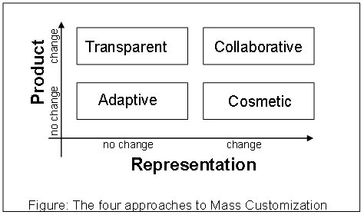

* Choice assistance system..
  + Know things like how you make a recommendation to your customers
    - Example, Dell takes your specs and makes recommendations
    - Or, movie reviews.. gives you suggestions



* Understand what system to use depending on how needs and interests are alike or different
  + Also consider whether attributes are hard to describe or easily quantified
    - For example, anything computer related.. like hard drive, easy to compare
    - Two hairstylists are hard to compare
  + Depending on these factors, some recommendation systems are better than others
* Multi channel approach
* E-Commerce

Online Shopping Process

Consumer e-commerce penetration by product category

* Online Shopping Process
  + On a website:



* M-Commerce
* Comparing stationary systems vs mobile platform
* Customer Behavior
  + How can data help?
  + Ex:
    - Transaction data -> Inventory, product selection, pricing, store layout, etc.
    - Profile + transaction data -> personalization, *shopping pattern, for example:
      * How to identify expecting mom’s (Target)